**Assignment - Monitoring, Scaling and Automation using AWS services**

**Problem Statement –**

Develop a system that automatically manages the lifecycle of a web application hosted on EC2 instances, monitors its health, and reacts to changes in traffic by scaling resources. Furthermore, administrators receive notifications regarding the infrastructure's health and scaling events.

**Infrastructure Automation:**

- Create a single script using `boto3` that: - Deploys the entire infrastructure. PFB details to perform -

**1.** **Web Application Deployment:**

- Use `boto3` to:

- Create an S3 bucket to store your web application's static files.

- Launch an EC2 instance and configure it as a web server (e.g., Apache, Nginx). - Deploy the web application onto the EC2 instance.

**2. Load Balancing with ELB:**

- Deploy an Application Load Balancer (ALB) using `boto3`.

- Register the EC2 instance(s) with the ALB.

**3. Auto Scaling Group (ASG) Configuration:**

- Using `boto3`, create an ASG with the deployed EC2 instance as a template.

- Configure scaling policies to scale in/out based on metrics like CPU utilization or network traffic.

**4. SNS Notifications:**

- Set up different SNS topics for different alerts (e.g., health issues, scaling events, high traffic).

- Integrate SNS with Lambda so that administrators receive SMS or email notifications.

**5. Infrastructure Automation:**

- Create a single script using `boto3` that:

- Deploys the entire infrastructure.

- Updates any component as required.

- Tears down everything when the application is no longer needed.

***PFB Screenshots for the Infrastructure Automation:***

1. Single boto3 Script for creation of the whole infrastructure.

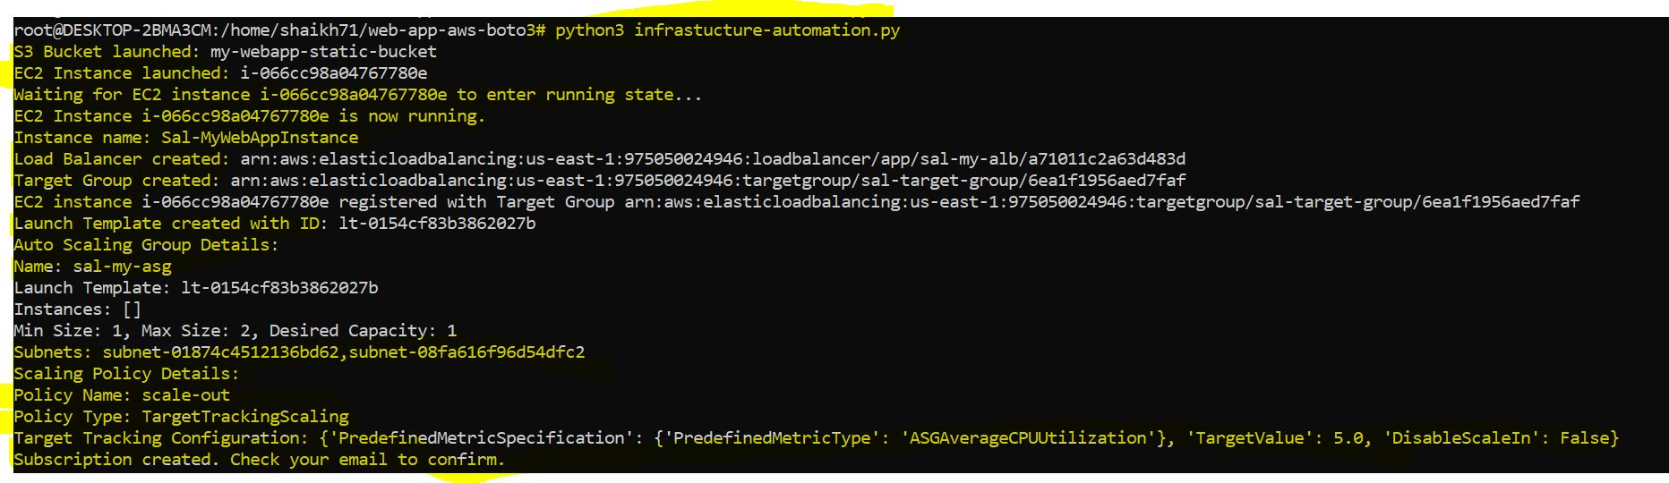

1. Step by step process in AWS after boto3 successfully ran the automation script.

* **S3 Bucket Created**

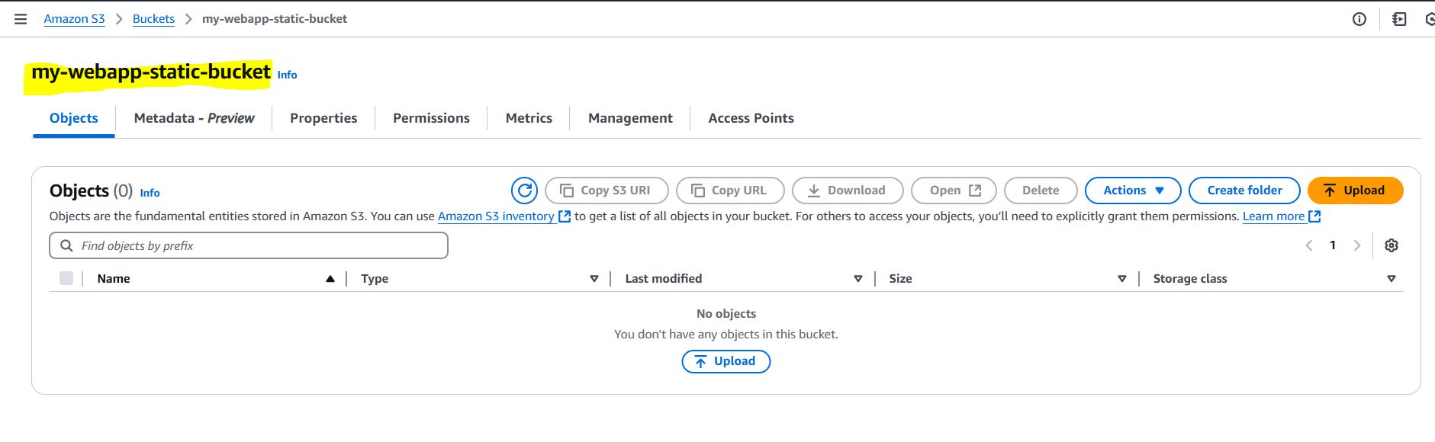

* **EC2 created**

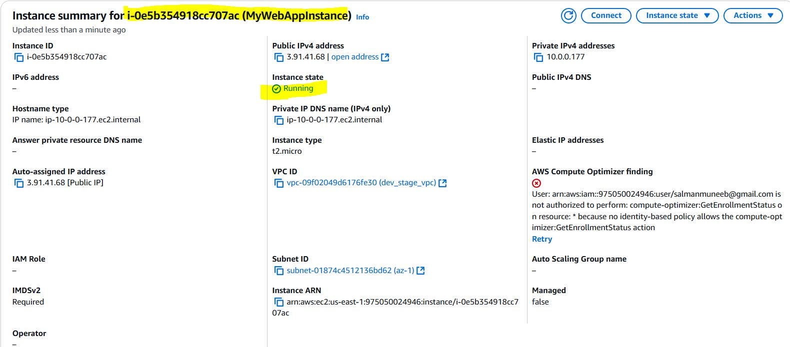

* **Load Balancer Created**

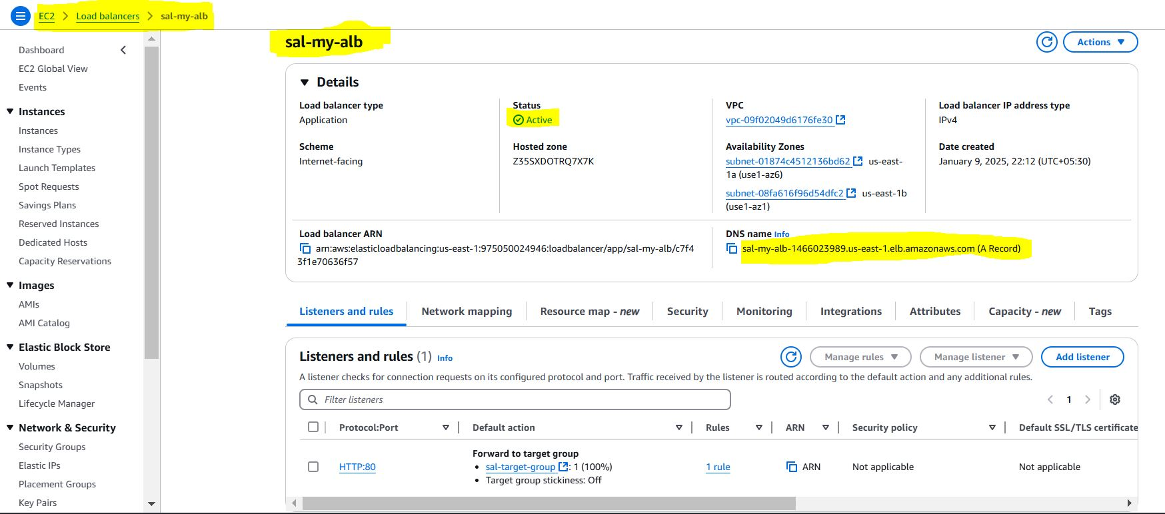

* **Load Balancer DNS working in Browser**

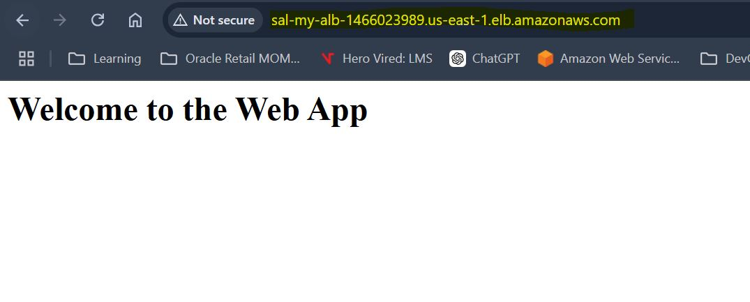

* **Target Group Created**

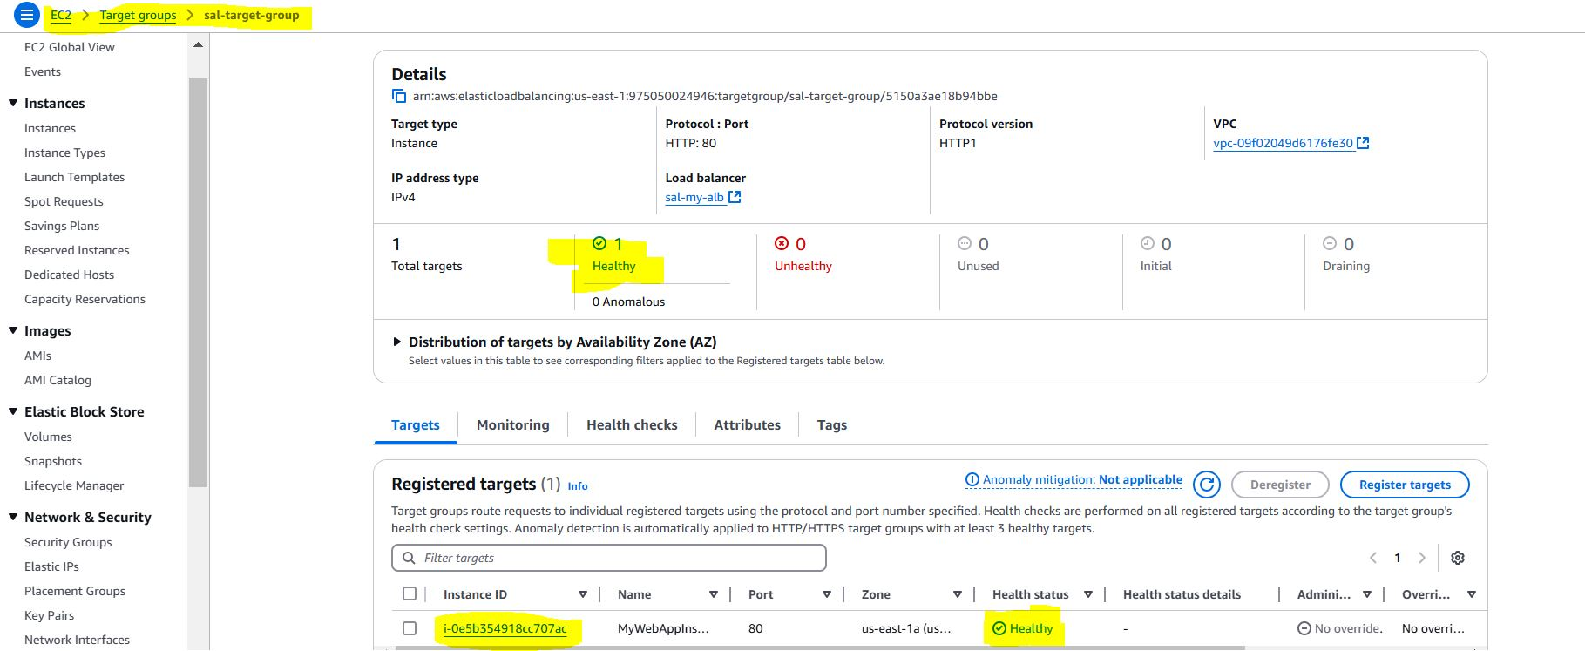

* **Auto Scaling Group Created**

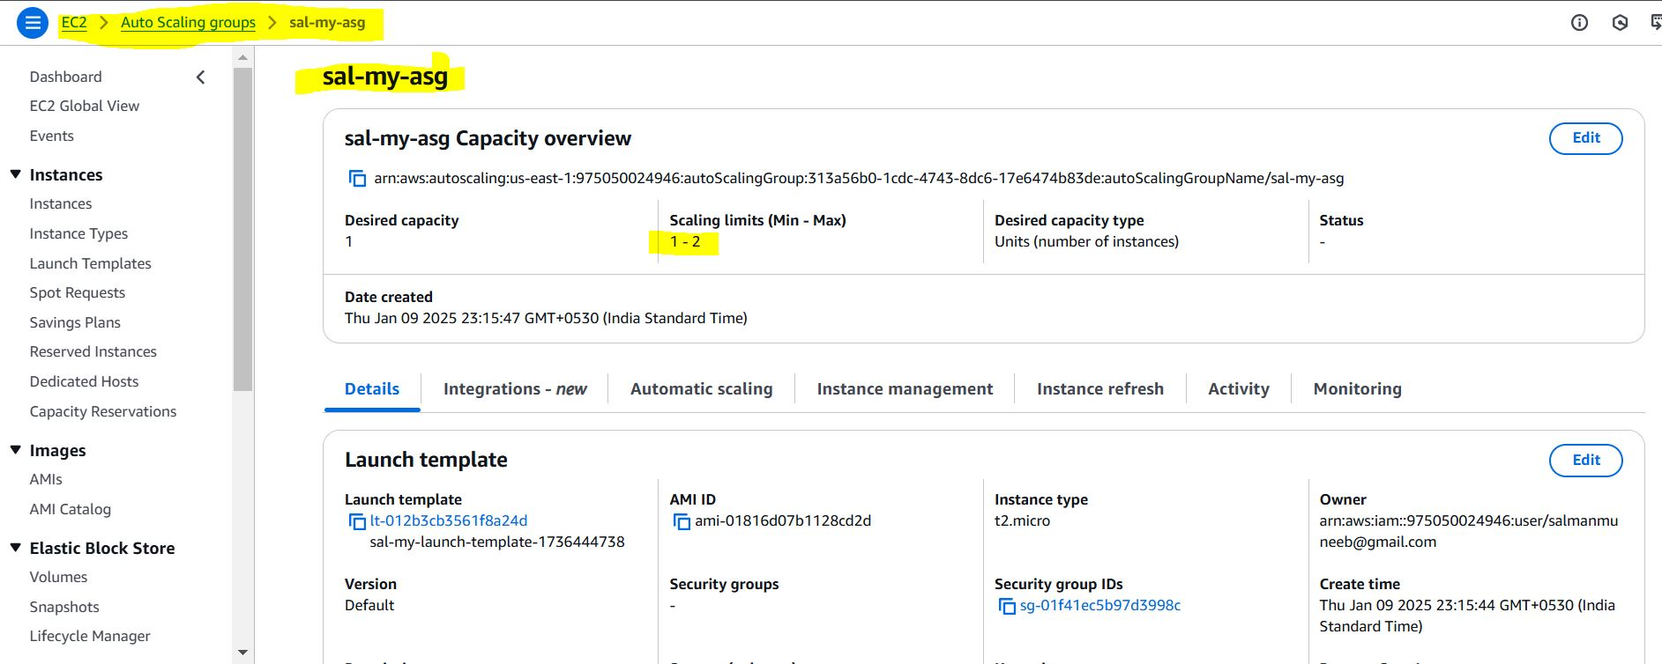

* **Launch Template Created**

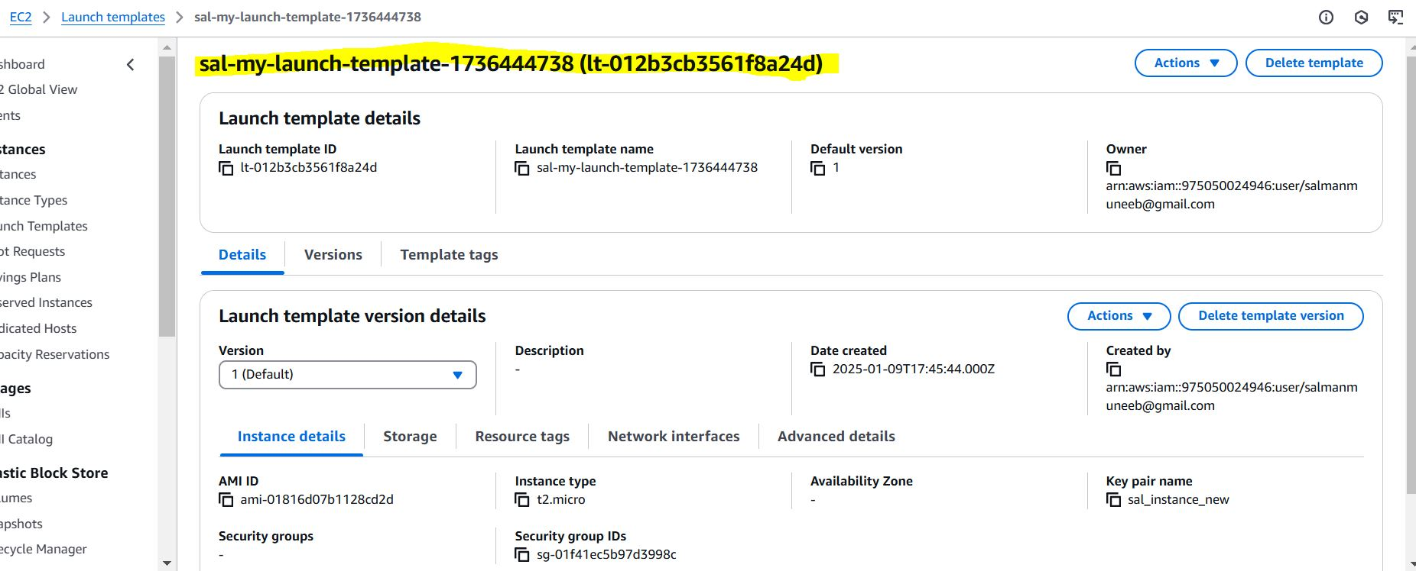

* **SNS created**

